Software Requirements

Specification

for

<Project>

Version 1.0 approved

Prepared by <author>

<organization>

<date created>

Software Requirements

Specification

for

<Project>

Version 1.0 approved

Prepared by <author>

<organization>

<date created>

Software Requirements

Specification

for

<Project>

Version 1.0 approved

Prepared by <author>

<organization>

<date created>

Software Requirements

Specification

for

<Project>

Version 1.0 approved

Prepared by <author>

<organization>

<date created>

Software Requirements

Specification

for

<Project>

Version 1.0 approved

Prepared by <author>

<organization>

<date created>

**Software Requirements Specifications**

**Company Directory**

Lucas Zuchinalli

18/02/2021

1. **INTRODUCTION**

This document is a response to the brief submitted by Paddy Evans. It presents a high level view of the main system functionality along with some sample screen layouts to facilitate better understanding of the proposed solution. Acceptance of this document by the sponsor will initiate a formal system development project that will be designed and built according to prevailing company standards.

1. **PRODUCT DECRIPTION** 
   1. **SCOPE**

The product is intended to be a stand-alone, single page application that is designed to be mobile first but works equally as well on desktops. The application will allow the user to manipulate the database using a simple interface which connects front-end components to server-side endpoints to achieve this result. The diagram below demonstrates the expected operation flow:

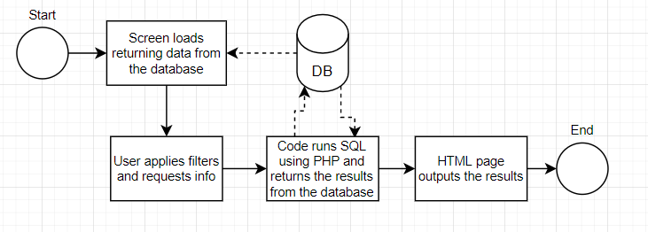

* 1. **PRODUCT FEATURES**

The application will be developed using the following:

* HTML/CSS (Bootstrap framework)
* JavaScript (jQuery framework)
* PHP (JSON data interchange)
* mySQL (Create, Read, Edit and Delete).

**2.2.1 SMALL SCREENS LAYOUT (APPLIES TO MOBILES AND SCREENS UP TO 728px PORTRAIT)**



To improve visualization to the user, we opt to display the personnel information as a list. Additional details will be display using a modal box when the user clicks on the desired employee (*Contact Info – see page 4*). A search box will be place on top to facilitate quick searches using the employee name.

Next to the search box, the menu button opens the filters option. The filter side bar contains a button to add new profiles (*Create Profile – see page 4*) and pre-set filters for department and location, the filter options will be automatically updated when new locations or departments are added to the database. A loading screen will appear while the query runs. There is also an option to Reset filters that cleans all the selected fields and displays all the users in the initial screens.

To improve functionality all the modal boxes will be used through all the screens sizes. Below you will find additional modals and their functionalities.

**Contact Info modal:** Will be displayed when the user selects to edit a profile information. From the modal box the user can edit, delete, or simply close the modal box using the icons on the modal header.



**Create Profile modal:** Will be displayed when the user selects create a new profile.



**Edit modal:** Will be displayed when the user selects to edit a profile information.



**2.2.2 BIG SCREENS LAYOUT (APPLIES TO LANDSCAPE SCREENS AT LEAST 1024px)**



Functionalities are kept from the previous layout, but now the side bar is fixed on the left of the screen and additional information will be displayed on the personnel table. The menu button will no longer be displayed. Components dimensions will be adjusted according to the screen size.

**2.2.3 COLOUR SCHEME:**

To create easily recognizable patterns and to make the user comfortable with our system, we created a colour pallet using flat shades. The colours will be repeatedly used in all the components.



Acceptance of this document will initiate the development of the system.

Sign off: Paddy Evans

............................................................................... Date